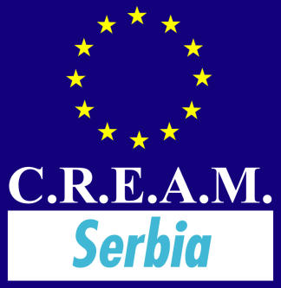

PRE-QUALIFICATION
QUESTIONAIRE
PPP ZRENJANIN WASTEWATER MANAGEMENT
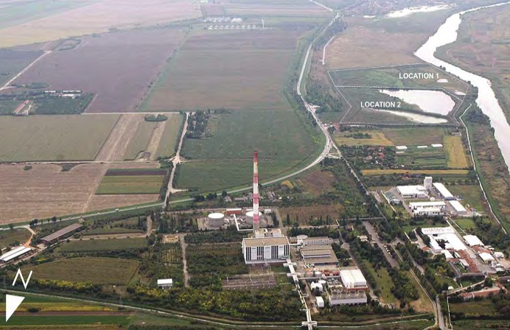

Pre-Qualification Questionnaire

CREAM Europe PPP Alliance  Office Berlin/Germany | CREAM Serbia PPP Alliance  Offices Novi Sad-Belgrade/Serbia
Dipl.-Ing. Ulrich Zimmermann, Friedrichstraße 90, D-10117 Berlin,  Tel.: +49 172 9312109  Fax: +49 17250 9312109  u.zimmermann@cream-europe.eu | Mile R. Jaksic  Futoška 1A  Kancelarija 205/II  Tel.: +381 64 248 00 02  m.jaksic@cream-europe.eu
www.cream-europe.eu

Contents
1 INTRODUCTION 4
2 PURPOSE OF THE MARKET RESEARCH 4
3 QUESTIONNAIRE 5
3.1 General Data 5
3.2 References 6
3.3 Questions 7

ANNEX
- Project Exposé Zrenjanin Wastewater Management
- Zrenjanin WWM Volume 1: NON-TECHNICAL SUMMARY
- Zrenjanin WWM Volume 2: FEASIBILITY STUDY
- Zrenjanin WWM Volume 3: APPENDICES
  - APPENDIX 1 AGGLOMERATION SCREENING
  - APPENDIX 2 COST BENEFIT ANALYSIS
  - APPENDIX 3 ENVIRONMENTAL AND SOCIAL APPRAISAL
  - APPENDIX 4 ENDORSEMENT LETTER

INTRODUCTION
The City of Zrenjanin has requested CREAM EUROPE PPP Alliance to facilitate a Market Research in connection with the possible procurement of Zrenjanin Wastewater Management as PPP-Project in Serbia.

The PPP-Project consists of the following main components:
• Measures for the improvement of the existing sewerage system Zrenjanin;
• Construction of new WWTP, location in Zrenjanin;
• Development and connection of the sewerage system Zrenjanin
to the new WWTP and to the settlements in the surrounding territory;

The aim of the Market Research is to build on the studies that have already been under taken, reconcile the different views that have been expressed and determine the best approach for the City of Zrenjanin. One strand of work currently being under taken is to identify important issues and key success factors regarding Commercial and Contractual strategies and organisational issues for the PPP. In connection with this strand of work limited market studies are being undertaken and you are invited to participate. The attached Project Exposé ZWM summarizes the background for the Market research, the structure of the current ZWM and the scope of a possible PPP at this stage. This Pre-Qualification Questionnaire contains the following list of issues for discussion. The issues will be discussed in personal interviews or by phone.

PURPOSE OF THE MARKET RESEARCH
The purpose of the Market Research now being undertaken is to gain an understanding of relevant private Companies views of what will be important, from an organisational, contractual and commercial perspective, to deliver successfully PPP ZWM.

Specifically, through the Pre-Qualification Questionnaire we wish to identify important issues that would make the PPP Project more or less attractive to relevant parties. At this stage the aim is not to assess whether there is sufficient interest among the different parties in the market to underpin the launch of such a project. It is however important to identify any key issues that would make the project unattractive to the different parties so that they can be addressed in the ultimate design of any PPP Model.

QUESTIONNAIRE

General Data
Company Information
Name
Street
City
Country
Internet (URL)
Contact
Person
Phone
Fax
E-Mail
Turnover €, net
2012-2014
Total
number of
employees
Business
activities

References

Name of project

Scope of work

Employer

Order volume € (net)

Year contract concluded

Name of project

Scope of work

Employer

Order volume € (net)

Year contract concluded

Questions

1st Question
What would attract you to participate?
(Size, state of preparation, risk allocation, interfaces, timescales etc.)

Response

2nd Question
What would make you consider carefully your participation? (as above)

Response

3rd Question
What would in your opinion be the top 3 risks in
design, construction, financing and operation of ZWM?

Response

4th Question
What would be good ways to induce life cycle cost (“LCC”) thinking?

Response

5th Question
What delivery activities – from design through to operations -
do you believe should be packaged together? Why?

Response

6th Question
What do you see as the key building blocks for successfully delivering
new WWTP and WW collection system?

Response

7th Question
What do you see as a good organizational model
for the delivery of a project of this nature?
PPP Model Concession?
PPP Model Management Partnership?
Others?

Response

8th Question
Are there any Wastewater Management procurement projects
that you would highlight as being a model approach?

Response

9th Question
What kind of financing would you propose for the PPP Project ZWM?

Response

10th Question
Would your company confirm an Expression of Interest (EOI)
for the PPP-Project ZWM?

Response

11th Question
Other issues? (Outsourcing, new product or services, Biogas)
Concerns? Recommendations?

Response

Date of interview:

Name of interviewed.

